Visionaire
Moments in Time
A PRICE GUIDE
2021-2022
Visionaire was created in 1989 by commercial and fashion photographer Nigel Blacker.
Our brief was to create compelling alternative and exciting wedding images and move away from the traditional approach by being inventive, fresh and dynamic.
To really capture the zest and spirit of the day through the lens.
Moments in time that can never be repeated!

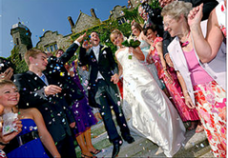 | 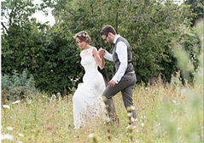 | 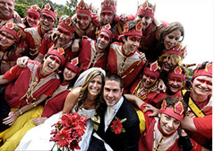
Hugo | Raphael | Genevieve
The Hugo wedding plan includes up to 10 hours of photography, from Bridal prep to evening Party shots, with approximately 450-650 carefully processed editorial quality images of the day’s events.  All pictures are downloaded onto a luxury glass or wooden USB memory stick, to print as many times as you wish.  Images are also uploaded to a complimentary online password-protected gallery, where friends and family can enjoy the photographs. | The Raphael wedding plan covers up to 10 hours of photography, from Bridal prep to Party shots late into the evening.  A beautiful contemporary Italian inspired, 10” x 10” wedding album will contain your choice of 60 optimised images, carefully designed within the book.  A luxury glass USB stick with approximately 450-650 enhanced editorial quality images, to print as many times as you wish.  Images are also uploaded to a complimentary online password-protected gallery, where friends and family can enjoy the photographs. | Our ultimate wedding plan provides up to 10 hours of photography, from Bridal prep through to late night Party shots!  An elite contemporary Italian inspired, 12” x 12” wedding album will contain your choice of 80 optimised images, carefully designed within the book.  In addition, a luxury glass or wooden USB stick will contain approximately 450-650 enhanced editorial quality images, to print as many times as you wish.  A selected 24” x 16” enlargement prepared and printed to exhibition standards.  Finally, images will be uploaded to a complimentary online password-protected gallery, where friends and family can enjoy the photographs.
£1,200 | £1,500 | £2,100
We are happy to customise our plan around your requirements! For example, please subtract £50 from your chosen plan’s price if you do not require, pre-wedding photography; or, subtract £100 from the price of your chosen plan if you do not require speeches and evening party shots.

An initial deposit of £300 is all that is required to book our services. The balance being due 14 days prior to your Wedding Day. We welcome all major Debit and Credit cards.

Being a photographer for over 30+ years you might imagine that I might get weary of weddings, but the truth is that the more I do, the more I'm inspired, I love to create the story of the day. From the tentative and often frenetic prep shots through to the excitement and tension of the ceremony, then on to the fun, vibrance, colours and passion…

I'm a storyteller!

Here is a brief biography of my career so far:

I am a professional Photographer with over 30 years’ experience.

From the age of 17, I developed a path into what has became a successful photographic career!
​
After a stint at Art College, I began my first full time role, shooting mostly archaeological bric-a-brac, from Neolithic flints to Roman pots.

As time passed, I began shooting more fashion and commercial images for advertising agencies. The work was very diverse, ranging from, Cars, to Food, Room Sets Fashion and Products.
​
However, as time went on I began to feel that the human element was
essentially missing from my images. So, in 1989, I finally immersed myself headlong into wedding capture, but at the same time styling my work to be genuinely creative and refreshing.
​

'I like to dance a line between informality

and creativity,

Fusing a documentary natural style

with Innovation!
​

My wedding work has been featured in a number of media:
Magazines, Television, Newspapers.

More recently, a number of my wedding images were used by
Nikon cameras for their 100th anniversary company
European celebration video.
​
I am lucky enough to have travelled to some of the most beautiful and exotic wedding locations in a long career, from London's Ritz hotel to the Amalfi coast in Italy.
Each location giving me the opportunity to add something
exciting and pictorially different.
Being

